1. A black screen with white text

   Description automatically generatedDisplay the name of the departments and the name of the projects under its control.
2. Display the full data about all the dependence associated with the name of the employee they depend on him/her.

1. Display the Projects full data of the projects with a name starts with **"a"** letter.

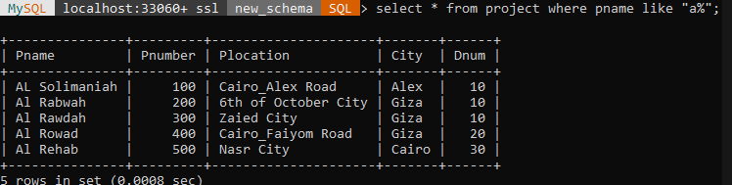

1. display all the employees in department 30 whose salary from 1000 to 2000 LE monthly

1. Retrieve the names of all employees in department 10 who works more than or equal10 hours per week on "AL Rabwah" project.

1. For each project, list the project name and the total hours per week (for all employees) spent on that project.

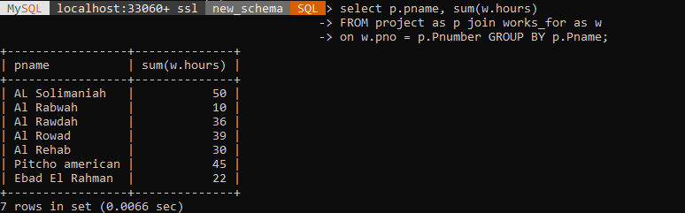

1. Retrieve the names of all employees and the names of the projects they are working on, sorted by the project name.

1. Display the data of the department which has the smallest employee ID over all employees' ID.

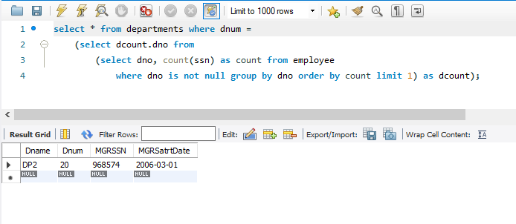

1. For each department, retrieve the department name and the maximum, minimum and average salary of its employees.

1. List the last name of all managers who have no dependents.

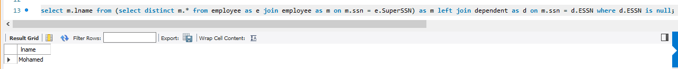

1. For each department-- if its average salary is less than the average salary of all employees-- display its number, name and number of its employees.

1. Retrieve a list of employees and the projects they are working on ordered by department and within each department, ordered alphabetically by last name, first name.

13. For each project located in Cairo, find the project number, the controlling department name, the department manager last name, address and birthdate.

